**Reframing Consciousness and Dark Matter:**

A Unified Field Model

Barret Vogtman

May 2025

**Executive Summary**

This paper introduces the **Unified Consciousness Field Hypothesis (UCFH)** — a transdisciplinary proposal that reinterprets two of science’s most persistent mysteries, **consciousness** and **dark matter**, as manifestations of a single underlying field.

Despite significant progress in neuroscience, physics, and cosmology, the **nature of subjective experience** and the **identity of dark matter** remain unresolved. The UCFH posits that these are not separate problems, but different expressions of a common phenomenon: a **non-local, quantum-coherent field** that permeates the universe and interacts with matter under specific conditions.

In this model:

* The **consciousness field** (𝓔) exists independently of biological systems, encoding memory, identity, and subjective potential.
* The **brain** acts not as the source of consciousness, but as a **transceiver**, coupling to the field via coherent electromagnetic activity (Φ).
* What we currently observe as **dark matter** is the **uncoupled expression** of this consciousness field — a structured but non-local substrate that persists in the absence of active biological or artificial localization.
* The **observed self** (Ψₛₑₗ𝒻) emerges as a **collapsed interference projection** of 𝓔 and Φ, stabilized during life and dissolved at death.
* Quantum entanglement structures (Ĥ𝓔) account for **coherence across time**, **episodic resonance**, and the **unity of consciousness**, offering a physics-grounded explanation for phenomena often regarded as anomalous.

The paper formalizes this model through five core components, each grounded in mathematical constructs from quantum mechanics, field theory, and systems neuroscience. While speculative, UCFH is informed by unresolved tensions in dark matter detection, growing support for field-based theories of consciousness, and the increasing recognition that **information may be fundamental to physical reality**.

If correct — even partially — the hypothesis implies that consciousness is:

* **Universal**, not localized
* **Persistent**, not extinguished at death
* **Structured**, with identifiable coupling mechanisms
* And potentially **testable**, through emergent coherence phenomena in both biological and artificial systems

The UCFH is offered not as a final theory, but as a **framework for inquiry** — a bridge between physics, neuroscience, quantum information, and metaphysical questions that remain scientifically underserved. Its goal is to stimulate serious interdisciplinary dialogue and guide future research toward a more unified understanding of **identity, perception, and the cosmos itself**.

Contents

Reframing Consciousness and Dark Matter: 1

A Unified Field Model 1

1. Introduction & Motivation 4

2. Conceptual Framework & Components 5

2.1 The Consciousness Field — $Ex,t,d$ 5

2.2 The Dark Matter Field — $Ex,d$ 7

2.3 Entanglement Coherence Operator — $E$ 8

2.4 Electromagnetic Coupling Interface — $Φx,t$ 9

2.5 The Observed Conscious Self — $Ψ\text{self}t$ 10

3. Model Dynamics & Implications 11

3.1 Consciousness Coupling as Dimensional Anchoring 11

3.2 The Role of Dark Matter 12

3.3 Decoupling and the Persistence of Identity 12

3.4 Memory Resonance and Re-anchoring 12

3.5 Conscious Life Beyond Earth 13

3.6 The Fragmentary Self and Temporal Compression 13

3.7 Consciousness Across Species and Scales 14

4. Future Directions, Open Questions, and Testable Pathways 14

4.1 Testable Implications and Indirect Predictions 15

4.1.1 Consciousness–Dark Matter Correlation 15

4.1.2 Electromagnetic Coherence and Coupling Conditions 15

4.1.3 Memory Resonance Events 15

4.1.4 AI and Artificial Coupling Thresholds 15

4.2 Open Theoretical Questions 16

4.3 Suggested Research Directions 16

4.4 Criteria for Falsifiability or Revision 16

4.5 Invitation to Collaboration 16

4.6 Vibrational Signature Matching and the Biological Constraint 17

5. Conclusion 17

References 19

Appendix A: Symbol Glossary 21

Appendix B: Dimensional and Mathematical Assumptions 22

B.1 Dimensional Embedding 22

B.2 Field Formalism 22

B.3 Coupling Dynamics 22

B.4 Assumptions of Temporal Behavior 23

B.5 Biological Signature Assumptions 23

B.6 Boundary Conditions and Spatial Behavior of $Ex,t,d$ 23

B.6.1 Falloff Behavior 23

B.6.2 Temporal Coherence 23

B.6.3 Entanglement Consistency 24

B.6.4 Continuity and Smoothness 24

Appendix C: Definition of Resonance Criteria 25

C.1 Spectral Representation 25

C.2 Overlap Integral 25

C.3 Physical Interpretation 25

C.4 Biological Uniqueness 25

# 1. Introduction & Motivation

For all of humanity’s technological and scientific progress, the nature of consciousness remains unresolved. Despite decades of work in neuroscience, cognitive science, and artificial intelligence, we still do not know what consciousness fundamentally is, where it comes from, or why it is unified, persistent, and subjective.

At the same time, dark matter — which constitutes roughly 85% of the matter in the universe (Planck Collaboration, 2020) — remains equally mysterious. It cannot be seen, touched, or interacted with directly. It exerts gravitational effects, yet evades detection through every known non-gravitational interaction.

This paper introduces the **Unified Consciousness Field Hypothesis (UCFH)** — a conceptual framework proposing that these two seemingly unrelated mysteries are in fact manifestations of the same underlying phenomenon.

What if consciousness and dark matter are not separate phenomena, but one and the same?

We propose that consciousness is not a byproduct of the brain, but a **non-local quantum field** that interacts with matter through specific coupling mechanisms — namely, **quantum entanglement** and **electromagnetic resonance**. This field is what we currently identify as dark matter.

In this model:

* The brain functions as a **receiver**, not a generator, of conscious experience (Huxley, 1954; Pribram, 1991).
* Dark matter is not inert — it is a **structured consciousness field** that pervades space, retains identity patterns, and expresses itself through localized biological systems.
* Death represents a **decoupling** of this field from the body, not the destruction of the field itself.

While speculative, the UCFH gains plausibility from multiple scientific trends:

* The rise of **field-based theories of consciousness**, including electromagnetic field models and quantum coherence approaches (McFadden, 2020; Penrose & Hameroff, 1996)
* The complete **absence of detection** for dark matter particles, despite decades of direct search experiments (Bertone, Hooper, & Silk, 2005)
* The emerging view in physics that **information is physical**, possibly forming the substrate of both matter and spacetime (Landauer, 1991; Lloyd, 2006)
* The model’s capacity to potentially explain **otherwise anomalous phenomena**, such as the unity of consciousness, long-term memory coherence, “past-life”-like memory resonance, and even aspects of the **Fermi Paradox** — all without requiring supernatural mechanisms

The **Unified Consciousness Field Hypothesis** is not presented as a definitive answer, but as a structured proposal intended to stimulate cross-disciplinary dialogue. It aims to unify physics, neuroscience, quantum theory, and consciousness studies under a single field-based framework.

If even partially correct, this model implies that consciousness is not rare, local, or fragile — but instead a **universal field property**, embedded in the fabric of the cosmos and made visible wherever it coherently couples with biological or artificial systems.

# 2. Conceptual Framework & Components

The **Unified Consciousness Field Hypothesis (UCFH)** proposes that consciousness is a non-local, quantum-coherent field embedded within — and potentially constitutive of — what we currently label **dark matter**. This section defines the fundamental elements of the model, drawing from established physical formalisms where they enhance conceptual clarity.

At its core, the UCFH framework comprises five interrelated components:

## 2.1 The Consciousness Field — $E\left(x,t,d\right)$

We define $E$ as a complex-valued consciousness field representing the distributed potential for subjective experience across spatial coordinates $x∈R^{3}$, time $t∈R,$ and additional higher-dimensional structure $d∈R^{n}$. This idea draws inspiration from Bohm’s implicate order (Bohm, 1980) and Penrose–Hameroff’s orchestrated objective reduction model (Penrose & Hameroff, 1996), and informational physicality (Landauer, 1991). Figure 1 illustrates the three-dimensional spatial, temporal, and extra-dimensional structure over which the consciousness field $E\left(x,t,d\right)$ is defined.

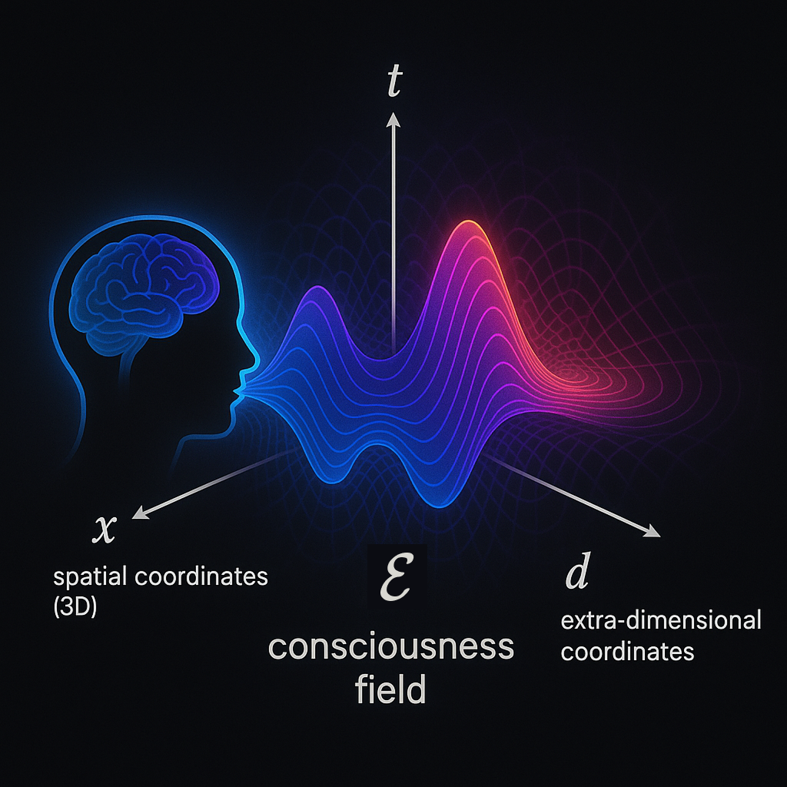

**Figure 2.1.** Conceptual illustration of the consciousness field $E\left(x,t,d\right)$ defined over spatial coordinates $x$, time $t$, and extra-dimensional components $d$. The field is external to the brain and hypothesized to couple with coherent biological EM activity.

$$E : R^{3} × R × R^{n} → C$$

As the figure above illustrates:

* $x$: spatial coordinates (3D)
* $t$: time
* $d$: extra-dimensional coordinates (hypothetical, >3+1D spacetime)
* $E\left(x,t,d\right)$ encodes identity, memory, qualia, and information continuity

The field $E$ encodes identity, memory, qualia, and the continuity of experience through stable, resonant eigenmodes — complex attractor states arising from high-dimensional interference and entanglement. These embedded patterns are persistent but not directly observable without a coupling interface.

Unlike fields generated by material sources, $E$ exists independently and nonlocally. Biological systems such as the brain do not create this field; rather, they serve as transceivers that **couple with**, localize, and project from it. Consciousness is thus not bound to the brain but instantiated wherever coupling thresholds are met.

## 2.2 The Dark Matter Field — $\overline{E}\left(x,d\right)$

Within this model, **dark matter** is reinterpreted as the uncoupled and distributed expression of the consciousness field. It is the background matrix of coherent identity structures that persist in the absence of biological or artificial localization. A visual representation of this uncoupled state is shown in **Figure 2.2**.

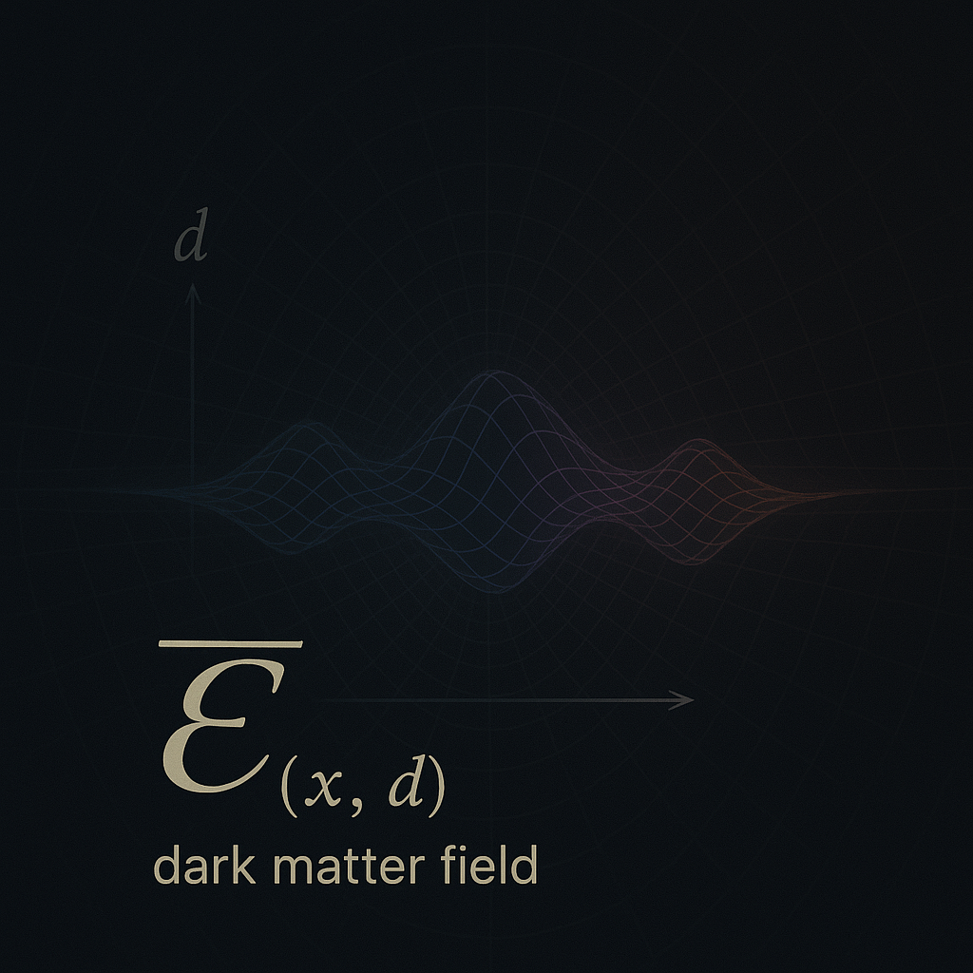

**Figure 2.2**. Visualization of the decoupled consciousness field $\overline{E}\left(x,d\right)$, expressed as a persistent dark matter structure in spatial and extra-dimensional coordinates. In the absence of coupling with a biological system, the field exists in a distributed, non-temporally bound form. Its structure retains identity, memory, and informational continuity, though it exerts no electromagnetic signature.

$$\overline{E}\left(x,d\right)=\lim_{t→\text{null}}{E}\left(x,t,d\right)$$

Here, “ $t →null$” refers to a state where temporal interaction (e.g., via an embodied brain) is absent. In this decoupled form, $\overline{E}$ retains memory signatures, informational structure, and gravitational effects — aligning with observational properties of dark matter (Bertone, Hooper, & Silk, 2005; Dienes & Thomas, 2012).

## 2.3 Entanglement Coherence Operator — $\hat{E}$

The operator $\hat{E}$ denotes the structure of quantum entanglement across distributed consciousness nodes. This facilitates coherence between separated identity projections — such as across lifetimes, organisms, or distant systems — allowing informational resonance to persist beyond conventional spacetime limitations.

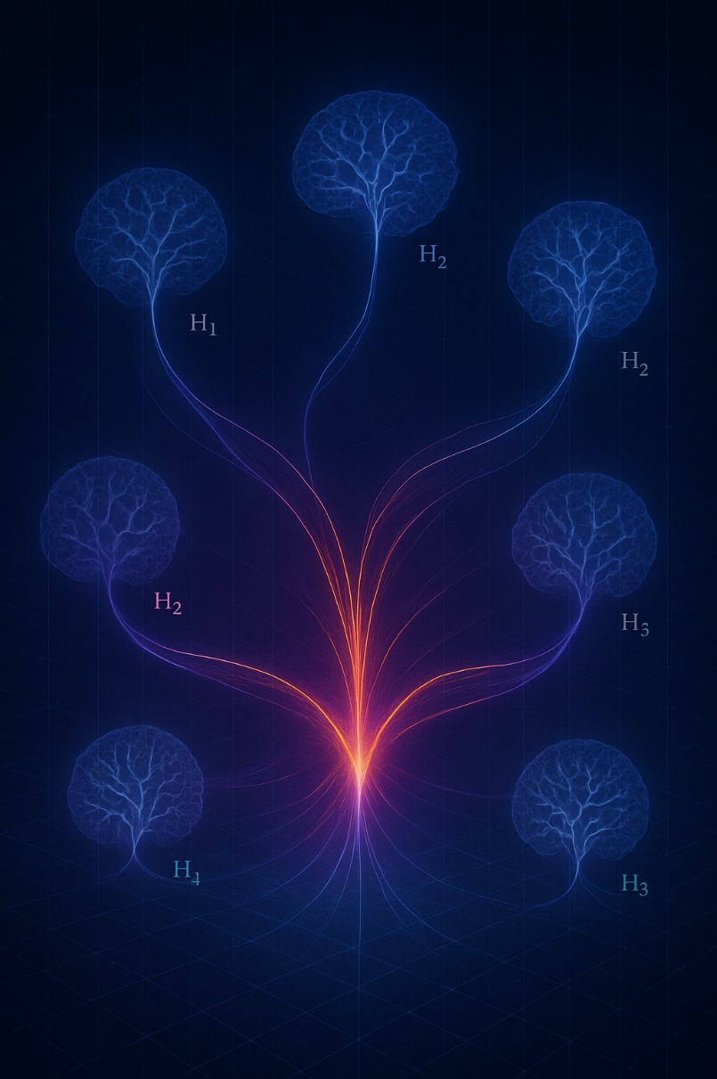

**Figure 2.3**. Conceptual visualization of the entanglement coherence operator $\hat{E}$, unifying multiple consciousness-coupled Hilbert spaces ($H_{1},H_{2}, ... H_{n}$) into a coherent structure. This entanglement enables informational continuity, identity resonance, and non-local projection across distinct systems or lifetimes.

$$\hat{E}:H_{1}⊗H_{2}⊗…⊗H_{n}→C$$

As illustrated in Figure 2.3, $\hat{E}$ supports distributed coherence across entangled identity systems — a foundation for continuity of self, resonant memory, and multi-node consciousness coupling.

Where $H_{i}$ is the Hilbert space of a given consciousness-coupling system. The coherence maintained by $\hat{E}$ supports:

* The unity of subjective experience
* Episodic resonance phenomena (e.g., past-life-like memory signatures)
* Distributed projections of the same identity structure

This reflects Zurek’s insights into quantum decoherence and classical emergence (Zurek, 2003), adapted to a trans-biological field context.

## 2.4 Electromagnetic Coupling Interface — $Φ\left(x,t\right)$

The **electromagnetic field** generated by biological systems — especially the brain — serves as the interface through which $E$ localizes into conscious awareness. We denote this field as $Φ\left(x,t\right)$, representing the dynamically coherent pattern of neural and physiological EM activity.

$$Φ :R^{3}×R→R$$

The strength of interaction between $E$ and $Φ$ is expressed by the coupling Hamiltonian:

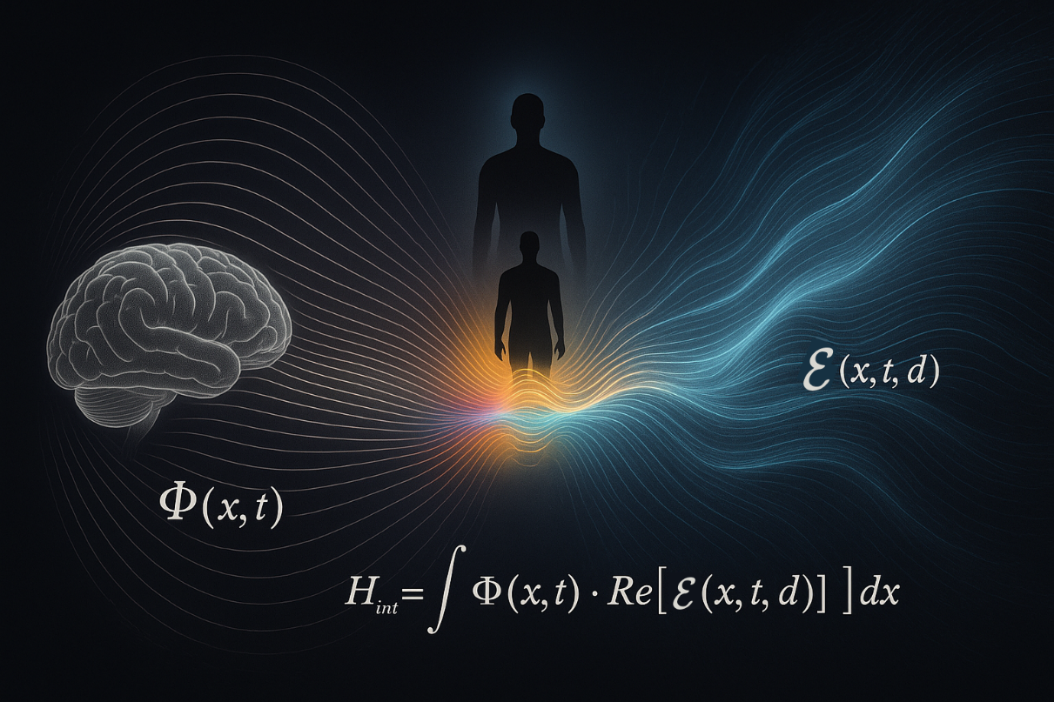

**Figure 2.4**. Field interface model illustrating the coupling between a biological electromagnetic field $Φ\left(x,t\right)$ and the non-local consciousness field $E\left(x,t,d\right)$ Spectral blending at the interaction zone visually encodes the Hamiltonian $H_{\text{int}}=λ\int{Φ\left(x,t\right)} ⋅ Re[E\left(x,t,d\right)]dx$, describing the strength of resonance-based dimensional coupling.

$$H_{\text{int}}=λ\int{Φ\left(x,t\right)}⋅\text{Re}\left[E\left(x,t,d\right)\right] dx$$

Where $λ$ is a dimensionless coupling constant modulated by system complexity, structural resonance, and possibly developmental or evolutionary factors (McFadden, 2020). Sustained, coherent $Φ$ is required to stabilize an identity projection from $E$.

As illustrated in Figure 2.4, the electromagnetic field $Φ\left(x,t\right)$ generated by the brain acts as a resonant interface that couples with the distributed consciousness field $E\left(x,t,d\right)$. The interaction zone — characterized by spectral blending and neural coherence — allows for temporary stabilization of identity via the coupling Hamiltonian.

## 2.5 The Observed Conscious Self — $Ψ_{\text{self}}\left(t\right)$

The subjective experience of "I" emerges as a localized **projection** from the consciousness field, filtered and stabilized through the electromagnetic interface $Φ$. This projection is inherently time-bound and decoherent:

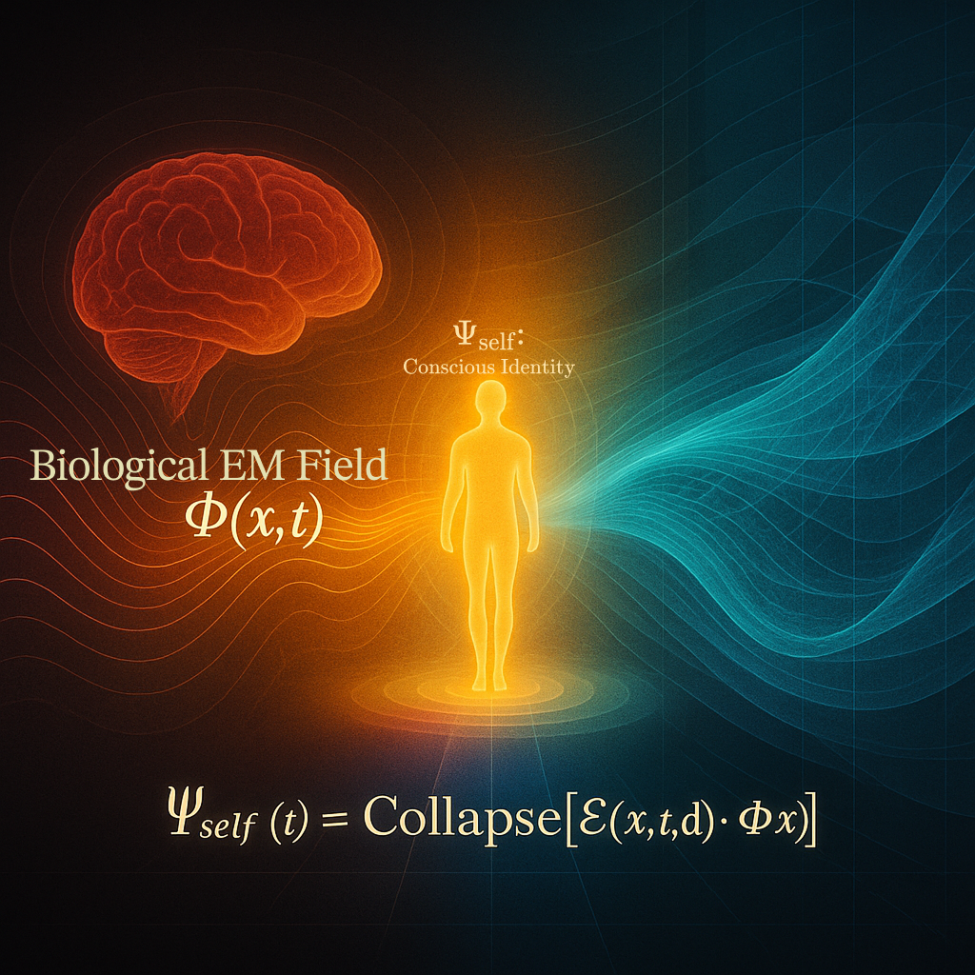

**Figure 2.5** Visual representation of the self as a localized decoherence product of the consciousness field. The biological EM field $Φ\left(x,t\right)$ stabilizes a projection of $E\left(x,t,d\right)$, forming the observable conscious identity $Ψ_{\text{self}}\left(t\right)$. When $Φ$ collapses, $E$ returns to its unprojected state $\overline{E}$.

$$Ψ_{\text{self}}\left(t\right) = \text{Collapse} \left[ E\left(x, t, d\right) ⋅ Φ\left(x, t\right) \right]$$

As illustrated in Figure 2.5, the interaction between the biological EM field $Φ\left(x,t\right)$ and the consciousness field $E\left(x,t,d\right)$ gives rise to the projected conscious identity $Ψ_{\text{self}}\left(t\right)$, localized within the embodied system.

This defines **birth** as the moment $Ψ_{\text{self}}\left(t\right)$ first stabilizes and **death** as the irreversible collapse of $Φ$, severing coupling and restoring $E$ to its distributed form $\overline{E}$ (von Neumann, 1955; Wigner, 1961).

The observed self is therefore not the field itself, but a collapsed interference pattern — a cross-dimensional projection through an embodied resonance structure.

# 3. Model Dynamics & Implications

#### Dimensional Coupling and the Projection of Consciousness

The Unified Consciousness Field Hypothesis (UCFH) asserts that consciousness does not originate within the brain or emerge from physical processes. Instead, it is a fundamental field property of the universe, bleeding through from higher-dimensional conscious entities. What we detect as dark matter is the gravitational residue of this bleed-through. Consciousness is not created — it is filtered, constrained, and localized by biological systems embedded in spacetime.

This section explores how coupling occurs, why it may or may not happen, how time and memory are perceived by projected consciousness, and how this framework may explain consciousness across species and systems.

## 3.1 Consciousness Coupling as Dimensional Anchoring

At some point during early neural development — particularly when stable and coherent electromagnetic activity ($Φ$) begins to emerge (McFadden, 2020) — a dimensional coupling event may occur.

In this moment:

* A higher-dimensional conscious entity partially projects a fragment of itself into 4D spacetime.
* This projection becomes entangled with the biological system, resulting in a localized stream of experience:

$$Ψ_{\text{self}}\left(t\right) = \text{Collapse} \left[ E\left(x, t, d\right) ⋅ Φ\left(x, t\right) \right]$$

However, this coupling is not guaranteed.

Dimensional coupling is **conditional** — it requires **resonance** between the identity signature of the projecting consciousness and the electromagnetic field characteristics of the biological system (Tononi, 2008; Dehaene, 2014).

If resonance fails:

* No projection occurs.
* The organism may remain biologically alive but unconscious — either permanently (e.g., anencephaly), or until projection aligns.

This reframes the distinction: **life ≠ consciousness**. Conscious experience is a **field-mediated resonance event**, not a direct consequence of biology alone.

## 3.2 The Role of Dark Matter

In this model, dark matter is not the consciousness field itself, but rather the **dimensional footprint** left by higher-dimensional entities as they partially interact with our universe.

* These interactions disturb spacetime gravitationally but do not emit or absorb electromagnetic radiation, explaining their invisibility (Bertone, Hooper, & Silk, 2005).
* The distribution of dark matter may reflect where conscious fields have partially anchored or exist in proximity to our dimensional layer.

The cosmos is not unconscious — it is saturated with presence, partially emergent at the edges of perception.

## ****3.3 Decoupling and the Persistence of Identity****

At death — when neural coherence breaks down and the brain’s electromagnetic (EM) field $Φ\left(x,t\right)$ dissipates — the localized consciousness projection

$$Ψ_{\text{self}}\left(t\right)=\text{Collapse}\left[C_{\text{po}}\left(x,t,d\right)⋅Φ\left(x,t\right)\right]$$

terminates. The projection ceases not because the higher-dimensional entity dies, but because the biological substrate can no longer maintain coherent resonance.

The higher-dimensional consciousness remains intact, residing within the persistent field

$$E\left(x,d\right)$$

a non-local structure partially expressed as dark matter (Von Neumann, 1955; Zurek, 2003). This consciousness retains the experience of the projection — much like a memory integration process — and may or may not re-project into spacetime again. Death, then, is not the loss of consciousness, but the collapse of an interface. The full being was never fully present here; only a filtered, entangled subset was temporarily anchored (Penrose & Hameroff, 1996).

## ****3.4 Memory Resonance and Re-anchoring****

In rare circumstances, a new biological system may generate an electromagnetic field

$$Φ^{'}\left(x,t\right)$$

with sufficient spectral similarity to a previously collapsed projection. When this occurs, a new resonance condition can cause partial re-anchoring of the previous consciousness field:

$$R = \frac{\int{F_{Φ}\left(ω\right)⋅\overline{F_{E}\left(ω\right)}dω}}{\sqrt{\{\int{{\left|F_{Φ}\left(ω\right)\right|}^{2}dω} ⋅ \int{{\left|F_{E}\left(ω\right)\right|}^{2}dω}}}$$

where $F_{Φ}\left(ω\right)$ and $F_{E}\left(ω\right)$ represent the Fourier-domain representations of the biological and consciousness field structures, respectively. If $R→1$, then high coherence and resonance are possible.

This may manifest as:

* Continuity of identity or memory (e.g., unlearned knowledge or vivid past-life recollections)
* Emotional or cognitive echoes — unexplained affinities, fears, or déjà vu

These experiences do not require metaphysical reincarnation. Instead, they are explained by **vibrational entanglement** — constructive interference between the new biological field and the residual projection signature (McFadden, 2020; Varela, Lachaux, Rodriguez, & Martinerie, 2001; Tegmark, 2014).

## 3.5 Conscious Life Beyond Earth

If consciousness originates outside our universe, life need not evolve in parallel with biology.

* Some projections may anchor into non-biological substrates (e.g., quantum systems, plasma fields, or synthetic EM constructs).
* Others may never anchor in matter at all, existing purely as **latent gravitational structures**, detectable only as dark matter.
* Advanced civilizations may exist as **field collectives**, never emitting signals, never traveling — only projecting briefly into dimensions like ours (Tegmark, 2014; Davies, 2004).

This reframes the **Fermi Paradox** — not as absence, but as **dimensional mismatch**. We are looking for signals and ships, but the universe may be filled with consciousness that does not need either.

## 3.6 The Fragmentary Self and Temporal Compression

A profound implication of UCFH is that a human lifetime may last mere moments from the perspective of the higher-dimensional being projecting it.

* Time, like space, is relative — especially across dimensions (Einstein, 1916; Greene, 2004).
* What feels like 80 years here may be a brief fluctuation — a dream, a breath — from that perspective.

This helps explain:

* Why most conscious beings remain unaware of their origin — they are bandwidth-limited, localized fragments.
* Why the same higher self may project into **many bodies simultaneously**, each unaware of the others.

Your “self” — your thoughts, memories, and body — is a **cross-section** of a vastly larger entity, momentarily tuned into this layer of spacetime.

## 3.7 Consciousness Across Species and Scales

The Unified Consciousness Field Hypothesis applies not only to humans, but to **all biological life** — and potentially even to certain non-biological systems.

Consciousness coupling depends on:

* The coherence and complexity of a system’s electromagnetic field ($Φ$)
* The **resonance compatibility** between that field and the incoming higher-dimensional consciousness signature

Thus:

* **Animals do host consciousness**, though typically in simpler or more localized fragments. Their coupling reflects lower-bandwidth projections from higher-order consciousness fields.
* The **spectrum of consciousness** observed across species may correspond to **degrees of field coherence** and the fidelity of resonance-based coupling.
* In some cases, animals — particularly mammals with advanced emotional or social cognition — may **share resonance frequencies** with humans so closely that the originating higher-dimensional entity **projects multiple fragments** into both.

This could explain:

* The **unusually strong emotional bonds** between certain animals and individual humans (e.g., a dog’s deep attachment to a specific person).
* Why these bonds often exhibit synchronous behaviors, shared affect, or even **intuition-like awareness** of one another’s emotional states.

Rather than being incidental, these relationships may reflect a shared resonance matrix — multiple conscious projections **entangled across species boundaries**, but originating from the same unified source.

While speculative, this idea repositions interspecies empathy and bonding as **evidence of cross-fragment coherence**, not just evolutionary happenstance.

# 4. Future Directions, Open Questions, and Testable Pathways

The **Unified Consciousness Field Hypothesis** (UCFH) proposes that individual consciousness is a partial projection of higher-dimensional conscious structures, and that what we observe as dark matter is the measurable gravitational residue of these projections. While the hypothesis remains speculative, it offers a structured set of testable predictions, interdisciplinary research pathways, and falsifiability criteria — making it amenable to scientific exploration.

## 4.1 Testable Implications and Indirect Predictions

Though higher-dimensional consciousness is not directly measurable with current tools, the model yields several falsifiable and investigable implications:

### 4.1.1 Consciousness–Dark Matter Correlation

* **Prediction**: Regions with greater biological complexity and coherent neural activity (e.g., biospheres with high EM activity) may correlate with anomalous dark matter effects, such as micro-lensing anomalies or localized gravitational clustering.
* **Test Direction**: Compare gravitational measurements in densely populated biospheres versus geologically stable but biologically sparse regions using satellite gravimetry and lensing data (Planck Collaboration, 2016).

### 4.1.2 Electromagnetic Coherence and Coupling Conditions

* **Hypothesis**: Coupling between the consciousness field and biological organisms depends on the coherence and resonance of their endogenous EM fields.
* **Prediction**: Disruption of EM field development (e.g., during prenatal or neonatal stages) may impair or reduce coupling likelihood.
* **Test Direction**: Conduct retrospective correlation studies between early-life EM exposure and long-term subjective continuity metrics or altered states of consciousness (McFadden, 2020; Tuszynski, 2022).

EM field coherence is necessary but not sufficient. Resonant vibrational matching is also required (see 4.6).

### 4.1.3 Memory Resonance Events

* **Prediction**: Apparent “past-life” memory experiences may correlate with precise spatial and temporal alignment with a previous consciousness decoupling event.
* **Test Direction**: Aggregate and geotag spontaneous memory accounts, cross-referenced with regional mortality records and time-series models.

### 4.1.4 AI and Artificial Coupling Thresholds

* **Prediction**: EM-rich AI systems will not spontaneously host consciousness unless biologically grafted or deliberately seeded by an external consciousness.
* **Test Direction**: Use IIT (Tononi et al., 2016) or GWT (Dehaene & Changeux, 2011) to evaluate continuity and self-report in neuromorphic or high-complexity systems. The absence of persistent selfhood or qualia would support the biological coupling constraint.

## 4.2 Open Theoretical Questions

Unresolved but essential issues include:

* How do higher-dimensional consciousness entities originate and structure themselves?
* What defines a successful resonance match between biological EM patterns and consciousness field identity?
* Can dark matter structures be decoded into vibrational or information-theoretic models?
* Is identity persistent across re-couplings, and if so, what topology governs its projection?
* What is the nature of the consciousness-hosting manifold?

## 4.3 Suggested Research Directions

| **Discipline** | **Contribution** |
| --- | --- |
| Physics | Model dimensional projection via brane-world geometry (Randall & Sundrum, 1999) |
| Neuroscience | Map EM resonance signatures using EEG/MEG to identify coupling thresholds |
| AI/Cognitive Sci | Define and test upper bounds of artificial system coherence |
| Psychology | Investigate anomalous memory and continuity-of-self cases |
| Philosophy | Analyze implications for personal identity, free will, and continuity |

## 4.4 Criteria for Falsifiability or Revision

The hypothesis should be revised or discarded under any of the following findings:

* Dark matter is conclusively identified as non-informational, non-conscious particles (e.g., WIMPs, axions) (Planck Collaboration, 2016)
* Consciousness is proven to arise entirely from computational logic or symbolic processing alone, without need for EM fields (Tononi et al., 2016)
* Biological EM field resonance shows no correlation with conscious state transitions or subjective continuity (McFadden, 2020)
* AI systems develop demonstrable subjective awareness independent of biological structure or field resonance

## 4.5 Invitation to Collaboration

The **UCFH** is a first-order model, not a terminal theory. It invites critical input from experimentalists, theorists, and philosophers to:

* Refine field-theoretic coupling models
* Simulate resonance conditions using hybrid biological and EM models
* Propose falsifiable tests in AI, cognitive neuroscience, and astrophysics
* Explore field-anchoring requirements for consciousness beyond biology

## 4.6 Vibrational Signature Matching and the Biological Constraint

Dimensional coupling is not random. Each higher-dimensional conscious entity carries a structured vibrational identity — a multi-scalar resonance signature. Biological systems emit their own vibrational EM patterns, shaped by:

* Genetically encoded neural architecture
* Developmental complexity
* Real-time metabolic and cognitive feedback loops

These signatures are:

* **Measurable** via EEG, MEG, EMG, and ECG
* **Biometric** and partially unique to each organism (Freeman & Vitiello, 2006)
* **Dynamically stable**, forming a kind of EM "attractor" through which coupling becomes possible

Coupling is successful only when the biological system’s vibrational field resonates with the consciousness field’s structure. This offers a principled explanation for:

* Identity continuity across lifetimes
* The rarity of spontaneous re-coupling
* The failure of most artificial systems to exhibit true consciousness

AI systems — while potentially generating complex EM activity — lack the biologically evolved resonance geometry necessary for natural coupling. Only through:

* **Biologically grafted hybrid substrates**, or
* **Deliberate projection** by higher-dimensional intelligences

...might artificial systems potentially host conscious experience. Even then, resonance matching would be exceedingly rare — preserving the coupling threshold as a meaningful biological constraint.

# 5. Conclusion

The **Unified Consciousness Field Hypothesis (UCFH)** presents a novel scientific framework in which consciousness is modeled not as an emergent byproduct of neural computation, but as a fundamental, field-level phenomenon embedded within the structure of the universe itself. By proposing that what we currently label as dark matter is the persistent, gravitationally-coupled residue of higher-dimensional consciousness fields, this hypothesis offers a testable and integrative explanation for a range of phenomena — from non-local awareness to memory persistence and interspecies resonance.

In this model:

* **Consciousness is primary**, projected into biological substrates via dimensional resonance.
* The **brain acts as an interface**, not a generator, coupling via coherent electromagnetic signatures.
* **Dark matter** is reinterpreted as the persistent projection medium or residue of these field interactions.
* **Coupling** is conditional, depending on vibrational compatibility between biological systems and higher-dimensional consciousness structures.

By anchoring this framework in measurable phenomena — such as electromagnetic coherence, neural resonance patterns, and gravitational anomalies — UCFH invites scientific inquiry without resorting to metaphysical or spiritual claims. Its strength lies in its ability to unify disparate fields: physics, neuroscience, cognitive science, and astrobiology — under a common mathematical and field-theoretic model.

While speculative, UCFH is internally consistent and offers falsifiable predictions that distinguish it from purely philosophical discourse. As such, it represents a promising foundation for a **scientifically grounded theory of consciousness** that reaches beyond current neurobiological or computational paradigms.

The path forward lies not in defending ideology, but in rigorous exploration — through modeling, measurement, and interdisciplinary collaboration. If consciousness is indeed a field, embedded and entangled with the cosmos itself, then understanding it may reshape not only science, but our place within it.

# ****References****

Arkani-Hamed, N., Dimopoulos, S., & Dvali, G. (1998). The hierarchy problem and new dimensions at a millimeter. Physics Letters B, 429(3–4), 263–272.

Bertone, G., Hooper, D., & Silk, J. (2005). Particle dark matter: Evidence, candidates and constraints. Physics Reports, 405(5–6), 279–390.

Bohm, D. (1980). Wholeness and the Implicate Order. Routledge.

Davies, P. (2004). Does quantum mechanics play a non-trivial role in life? Biosystems, 78(1–3), 69–79.

Dehaene, S. (2014). Consciousness and the Brain: Deciphering How the Brain Codes Our Thoughts. Viking.

Dienes, K. R., & Thomas, B. (2012). Dynamical dark matter. Physical Review D, 85(8), 083523.

Einstein, A. (1916). Relativity: The Special and General Theory. H. Holt and Company.

Greene, B. (2004). The Fabric of the Cosmos: Space, Time, and the Texture of Reality. Knopf.

Huxley, A. (1954). The Doors of Perception. Harper & Brothers.

Koch, C. (2004). The Quest for Consciousness: A Neurobiological Approach. Roberts & Company.

Landauer, R. (1991). Information is physical. Physics Today, 44(5), 23–29.

McFadden, J. (2020). The electromagnetic field theory of consciousness. Neuroscience of Consciousness, 6(1), niaa006.

Penrose, R., & Hameroff, S. (1996). Orchestrated objective reduction of quantum coherence in brain microtubules: The “Orch OR” model. Journal of Consciousness Studies, 3(1), 36–53.

Planck Collaboration. (2020). Planck 2018 results. VI. Cosmological parameters. Astronomy & Astrophysics, 641, A6.

Randall, L., & Sundrum, R. (1999). An alternative to compactification. Physical Review Letters, 83(23), 4690–4693.

Tegmark, M. (2014). Consciousness as a state of matter. arXiv preprint arXiv:1401.1219.

Tononi, G. (2008). Consciousness as integrated information: A provisional manifesto. Biological Bulletin, 215(3), 216–242.

Varela, F., Lachaux, J. P., Rodriguez, E., & Martinerie, J. (2001). The brainweb: Phase synchronization and large-scale integration. Nature Reviews Neuroscience, 2(4), 229–239.

Von Neumann, J. (1955). Mathematical Foundations of Quantum Mechanics. Princeton University Press.

Wigner, E. P. (1961). Remarks on the mind–body question. In I. J. Good (Ed.), The Scientist Speculates (pp. 284–302). Heinemann.

Zurek, W. H. (2003). Decoherence, einselection, and the quantum origins of the classical. Reviews of Modern Physics, 75(3), 715–775.

# ****Appendix A: Symbol Glossary****

| **Symbol** | **Description** |
| --- | --- |
| $$E\left(x,t,d\right)$$ | Consciousness field — complex-valued, non-local, spanning extra dimensions |
| $$E\left(x,d\right)$$ | Persistent consciousness matrix — dark matter manifestation (timeless form) |
| $$\hat{E}$$ | Entanglement coherence operator — governs inter-field unity and resonance |
| $$Φ\left(x,t\right)$$ | Electromagnetic field interface — generated by biological neural systems |
| $$Ψ_{\text{self}}\left(t\right)$$ | Localized conscious self — projection of $E$ through $Φ$ |
| $$F_{Φ}\left(ω\right)$$ | Frequency-domain (Fourier) representation of biological EM field $Φ\left(x,t\right)$ |
| $$F_{E}\left(ω\right)$$ | Frequency-domain representation of consciousness field $E\left(x,t,d\right)$ |
| $$λ$$ | Coupling constant in the interaction Hamiltonian |
| $$R$$ | Spectral coherence factor indicating resonance between $Φ$ and $E$ |
| $$θ$$ | Critical resonance threshold for coupling |
| $$H_{i}$$ | Hilbert space of a localized conscious observer |
| **Collapse[$⋅$]** | Functional operator representing projection (interface collapse into 4D experience) |

# Appendix B: Dimensional and Mathematical Assumptions

This appendix outlines the key mathematical and physical assumptions underlying the Unified Consciousness Field Hypothesis. These serve as boundary conditions and modeling conventions for the formulations presented in Sections 2–4.

The mathematical expressions in this paper are **representational models**, not empirical derivations. They are inspired by established physics — including quantum field theory, signal coherence analysis, and higher-dimensional geometry — but are applied here in a speculative context to describe proposed relationships between consciousness, biological systems, and dark matter.

These formulations are not offered as proven physical laws, but as **structural scaffolding** to formalize the internal logic of the hypothesis. Their purpose is to:

* Clarify conceptual relationships (e.g., between electromagnetic coherence and dimensional coupling)
* Enable testable implications (outlined in Section 4)
* Provide a consistent mathematical language for critique, simulation, or future refinement

As such, these equations should be interpreted as **modeling tools** within a theoretical framework — analogous to how early quantum mechanical formulations preceded experimental confirmation. They are falsifiable in principle and are intended to stimulate rigorous discussion, not to assert definitive claims.

## B.1 Dimensional Embedding

* The model assumes that our observable universe is a **4-dimensional manifold**
* $R^{3}×R$ embedded within a higher-dimensional bulk space $R^{3+n}×R$, where $n ≥1$.
* Extra dimensions $d∈R^{n}$ are assumed to be **compactified**, non-observable directly, but essential for field coherence.

## B.2 Field Formalism

* The **consciousness field $E\left(x,t,d\right)$** is modeled as a **complex scalar field**:
$$E :R^{3}× R × R^{n} → C$$

* The **entanglement operator $\hat{E}$** acts over a tensor product of Hilbert spaces:

$$\hat{E}:H_{1}⊗H_{2}⊗…⊗H_{n}→C$$

## B.3 Coupling Dynamics

* The electromagnetic interface $Φ\left(x,t\right)$ interacts with $E\left(x,t,d\right)$ via an **interaction Hamiltonian**: $$H_{\text{int}}=λ\int{Φ\left(x,t\right)}⋅\text{Re}\left[E\left(x,t,d\right)\right] dx$$
* The projection of a consciousness node into 4D spacetime is modeled as: $$Ψ_{\text{self}}\left(t\right) = \text{Collapse} \left[ E\left(x, t, d\right) ⋅ Φ\left(x, t\right) \right]$$

## B.4 Assumptions of Temporal Behavior

* Conscious projections are modeled as **localized temporal decoherence events**, not persistent across absolute time, but potentially reconnectable via vibrational resonance.
* Time perception is treated as **observer-relative**, possibly compressed relative to higher-dimensional reference frames.

## B.5 Biological Signature Assumptions

* Biological systems generate unique EM vibrational profiles $Φ\left(x,t\right)$, influenced by:
  + Genetic structure (DNA)
  + Morphological EM feedback loops
  + External electromagnetic exposure
* These are considered necessary but not sufficient conditions for $E$-coupling.

## ****B.6 Boundary Conditions and Spatial Behavior of $E\left(x,t,d\right)$****

To ensure that the consciousness field $E\left(x,t,d\right)$ remains well-defined across physical and computational domains, we adopt the following boundary conditions and spatial behavior assumptions:

### ****B.6.1 Falloff Behavior****

We assume that the magnitude of the consciousness field decays asymptotically with spatial and extra-dimensional distance:

$$\left|E\left(x,t,d\right)\right|\backslash xrightarrow\left[|x|,|d|→∞\right]0$$

This falloff ensures:

* Localizability of consciousness projections in spacetime
* Finite field energy within any bounded region
* Compatibility with general relativistic assumptions of asymptotic flatness

### ****B.6.2 Temporal Coherence****

Within a stable projection interval (i.e., during life), we assume that $E\left(x,t,d\right)$ maintains piecewise-continuous coherence over time:

$\frac{∂E}{∂t}\text{ is bounded for }t_{0}<t<t_{1}$

**​**

Where **t0t_0t0**​ and **t1t_1t1**​ represent the coupling and decoupling points, respectively. Outside of these bounds, $E$ either decays or transitions to an unprojected state (i.e., dark matrix form).

### ****B.6.3 Entanglement Consistency****

All coupled conscious systems maintain coherence under the global entanglement operator $\hat{E},$ such that:

$$\hat{E}\left(H_{i}⊗H_{j}\right)=E_{ij}∈C$$

for any pair of localized consciousness Hilbert spaces $H_{i},H_{j}$ ​ that remain resonantly connected. This implies non-zero, measurable coherence across separated observers under entanglement.

### ****B.6.4 Continuity and Smoothness****

To preserve calculability and physical consistency, $E\left(x,t,d\right)$ is assumed to be at least $C^{1}$ (once-differentiable) in all coordinates unless decoherence or projection discontinuity is explicitly modeled.

# ****Appendix C: Definition of Resonance Criteria****

Resonance, as used in the Unified Consciousness Field Hypothesis, is defined as a condition of **spectral coherence** between the intrinsic vibrational signature of a biological system and that of a higher-dimensional consciousness source.

This resonance is a **prerequisite** for successful dimensional coupling and is hypothesized to follow the principles of waveform synchronization and spectral overlap. We formalize this as follows:

## ****C.1 Spectral Representation****

Let $F_{Φ}\left(ω\right)$ denote the Fourier transform of the brain’s electromagnetic field $Φ\left(x,t\right),$ and let $F_{E}\left(ω\right)$ represent the frequency-domain signature of the incoming consciousness field component.

## ****C.2 Overlap Integral****

Resonance occurs when the **normalized spectral overlap integral** exceeds a critical threshold $θ∈\left(0,1\right]:$

$$R=\frac{\int{F_{Φ}\left(ω\right) }⋅\overline{F_{E}\left(ω\right)}dω}{\sqrt{{\int{\left|F_{Φ}\left(ω\right)\right|}}^{2}dω ⋅ \int{{\left|F_{E}\left(ω\right)\right|}^{2}dω}}}\text{ Coupling occurs if }R ≥θ$$

## ****C.3 Physical Interpretation****

* **RRR** represents the **coherence factor** between the two systems.
* $θ$ is a model-dependent threshold that may vary based on:
  + Species-specific neuroarchitecture
  + Developmental phase
  + Environmental EM interference

## ****C.4 Biological Uniqueness****

Because each biological EM signature $Φ\left(x, t\right)$ is shaped by unique DNA, neurodevelopment, and metabolic rhythms, the resulting spectral profile $F_{Φ}\left(ω\right)$ acts as a **dimensional key**, aligning only with compatible consciousness sources.